LAB EXPERIMENT RECORD
SET 8: EMPLOYEE PERFORMANCE ANALYSIS
Department | AIDS
Course Code / Course Name | DSA0601 / Data Handling and Visualization
Experiment | Data Visualization using R
Name | B. Pallavi
Register Number | 192424243
Date | 03 October 2026
Day | Saaturday

Aim
To visualize employee performance data using a line chart, bar chart, and performance table, and to build an interactive dashboard using R and Tableau.
Dataset: Employee Performance
Employee ID | Department | Years of Service | Performance Score
1 | Sales | 5 | 85
2 | HR | 3 | 92
3 | Marketing | 7 | 78

PROGRAM 1: Line Chart of Employee Performance
Create a line chart to visualize the performance trend of employees over years of service. Label the axes and title the chart.
# Dataset
employee_id <- c(1, 2, 3)
years <- c(5, 3, 7)
performance <- c(85, 92, 78)
# Line Chart
plot(years, performance,
type = "o",
xlab = "Years of Service",
ylab = "Performance Score",
main = "Employee Performance Trend",
pch = 19,
col = "blue")
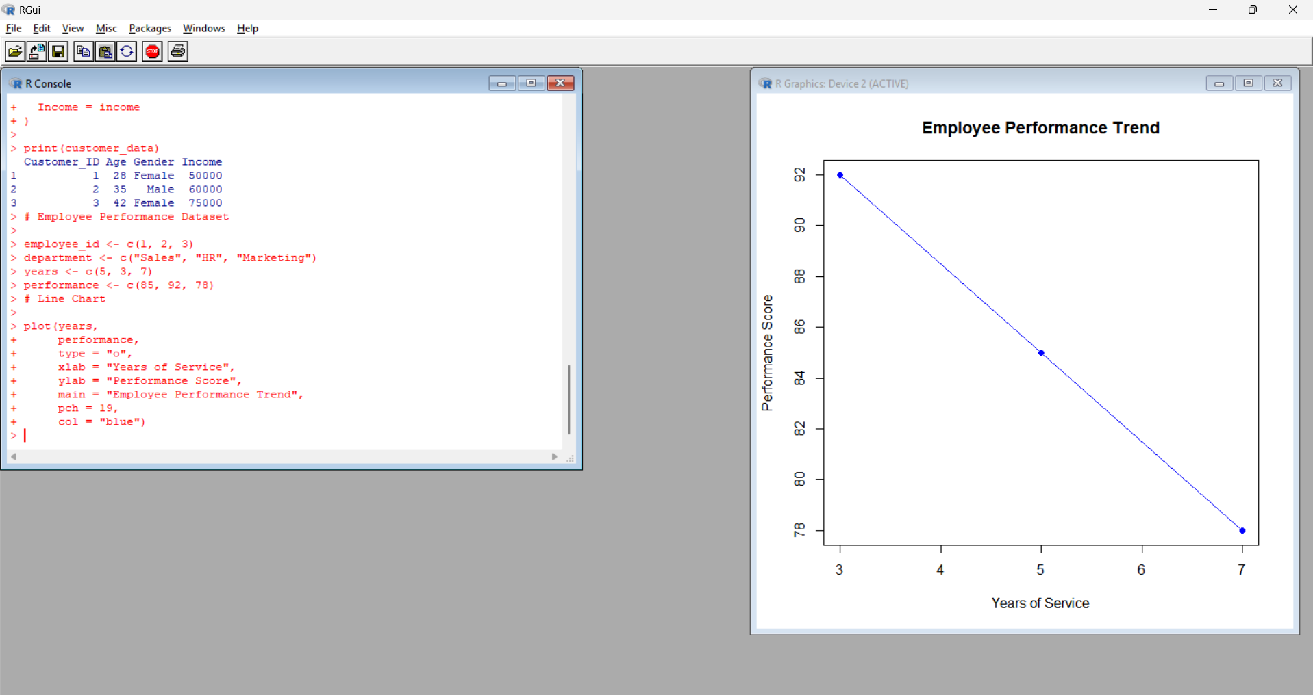
Output 1: Employee Performance Trend
Observation:
The line chart shows the relationship between years of service and performance score. Employee 2 has the highest performance score of 92 with 3 years of service, while Employee 3 has the lowest score of 78 with 7 years of service.
PROGRAM 2: Bar Chart of Employees by Department
Generate a bar chart showing the distribution of employees across different departments.
# Department Dataset
department <- c("Sales", "HR", "Marketing")
# Count employees
department_count <- table(department)
# Bar Chart
barplot(department_count,
xlab = "Department",
ylab = "Number of Employees",
main = "Employees by Department",
col = "lightgreen")
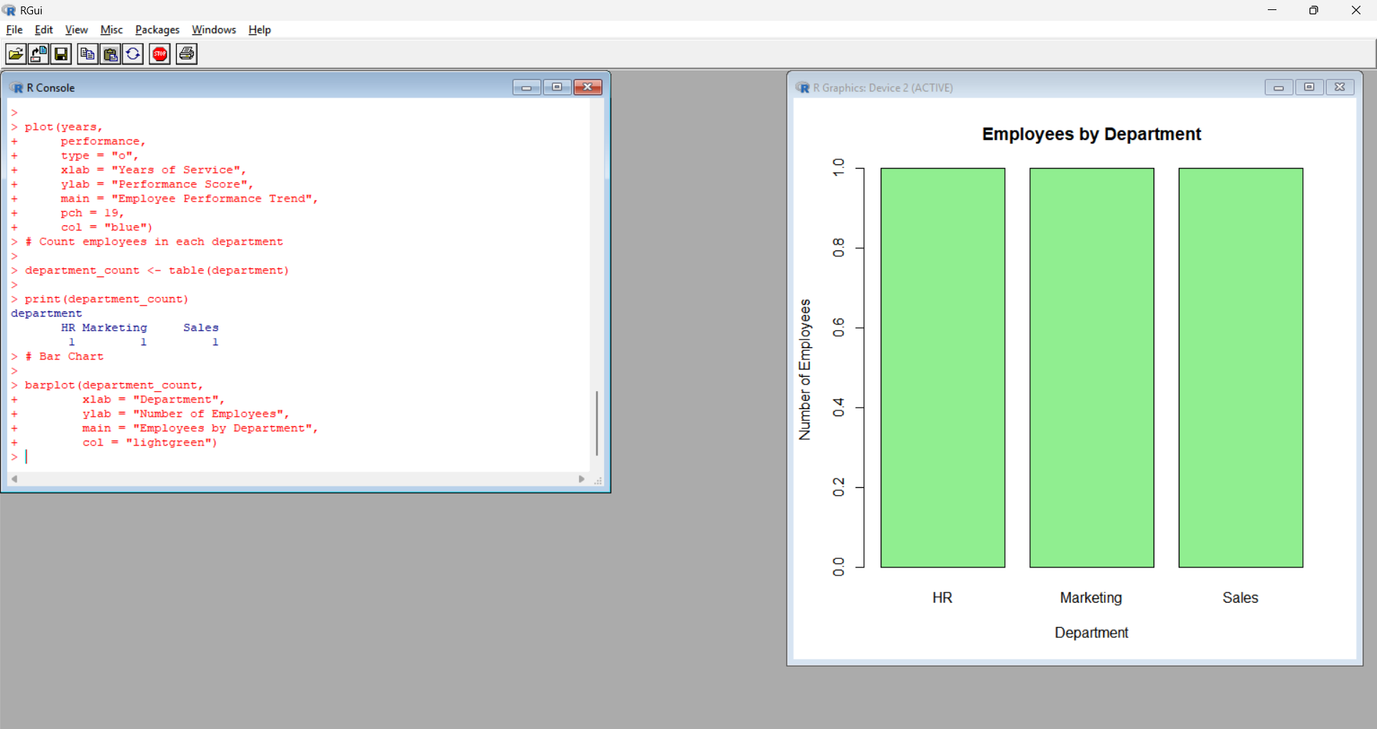
Output 2: Employees by Department Bar Chart
Observation:
The bar chart shows the number of employees in each department. Each department contains one employee in the given dataset.
PROGRAM 3: Employee Performance Table
Build a table to display the performance data for each employee.
# Employee Data
employee_data <- data.frame(
Employee_ID = c(1, 2, 3),
Department = c("Sales", "HR", "Marketing"),
Years_of_Service = c(5, 3, 7),
Performance_Score = c(85, 92, 78)
)
# Display Table
print(employee_data)
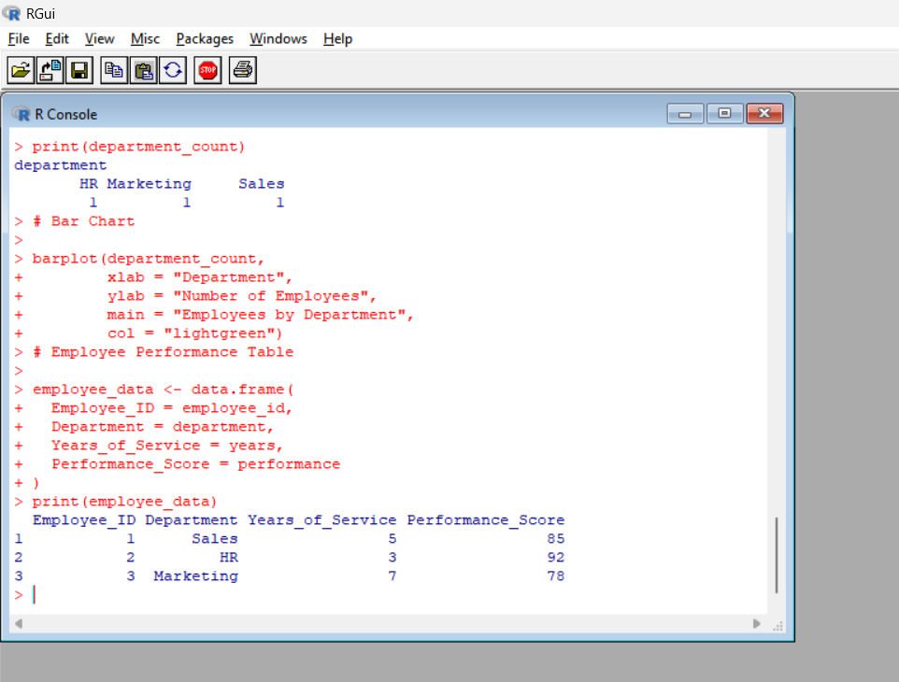
Output 3: Employee Performance Table
Employee ID | Department | Years of Service | Performance Score
1 | Sales | 5 | 85
2 | HR | 3 | 92
3 | Marketing | 7 | 78
Observation:
The table displays complete performance information for each employee, including department, years of service, and performance score.
PROGRAM 4: Interactive Employee Performance Dashboard
Build an interactive Tableau dashboard combining the line chart, bar chart, and performance table.
Dataset for Tableau
Create an Excel file with the following data:
Employee ID | Department | Years of Service | Performance Score
1 | Sales | 5 | 85
2 | HR | 3 | 92
3 | Marketing | 7 | 78
Save the file as:
Employee_Performance.xlsx
Tableau Steps
- Open Tableau.
- Select Microsoft Excel.
- Open Employee_Performance.xlsx.
- Select Sheet 1.
- Drag Years of Service to Columns.
- Drag Performance Score to Rows.
- Select Line from the Marks card.
- Drag Employee ID to Label.
- Rename the sheet Performance Trend.
- Create a new worksheet.
- Drag Department to Columns.
- Drag Employee ID to Rows.
- Select Bar from the Marks card.
- Select Label → Show Mark Labels.
- Rename the sheet Employees by Department.
- Create a new worksheet.
- Drag Employee ID, Department, Years of Service, and Performance Score to the view.
- Select Text Table.
- Rename the sheet Employee Performance Table.
- Click New Dashboard.
- Drag Performance Trend into the dashboard.
- Drag Employees by Department into the dashboard.
- Drag Employee Performance Table into the dashboard.
- Set the title as Employee Performance Analysis Dashboard.
- Select Use as Filter to make the dashboard interactive.
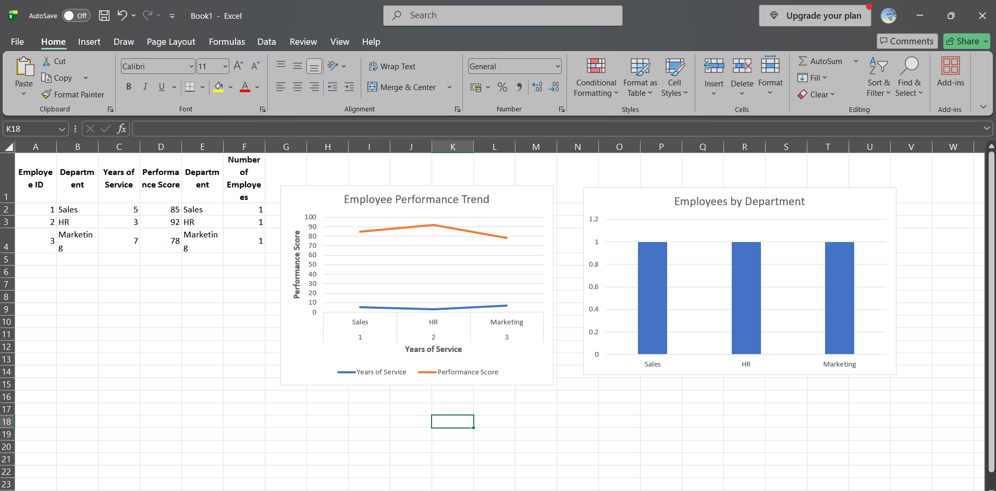
Output 4: Employee Performance Analysis Dashboard
Observation:
The dashboard combines employee performance trends, department distribution, and detailed employee information into a single interactive view. It allows users to compare performance scores and explore employee details.

Procedure
- Create employee and performance vectors in R.
- Use plot() to create the employee performance line chart.
- Create department values and use table() and barplot() to generate the department bar chart.
- Create a data frame to display employee performance information.
- Create an Excel file containing employee performance information.
- Connect the Excel file to Tableau.
- Create the performance trend line chart.
- Create the department bar chart.
- Create the employee performance table.
- Combine all three views into an interactive dashboard.
Result
The employee performance data was successfully visualized using a line chart, bar chart, and performance table. An interactive Tableau dashboard was also created to display employee performance and department information.

